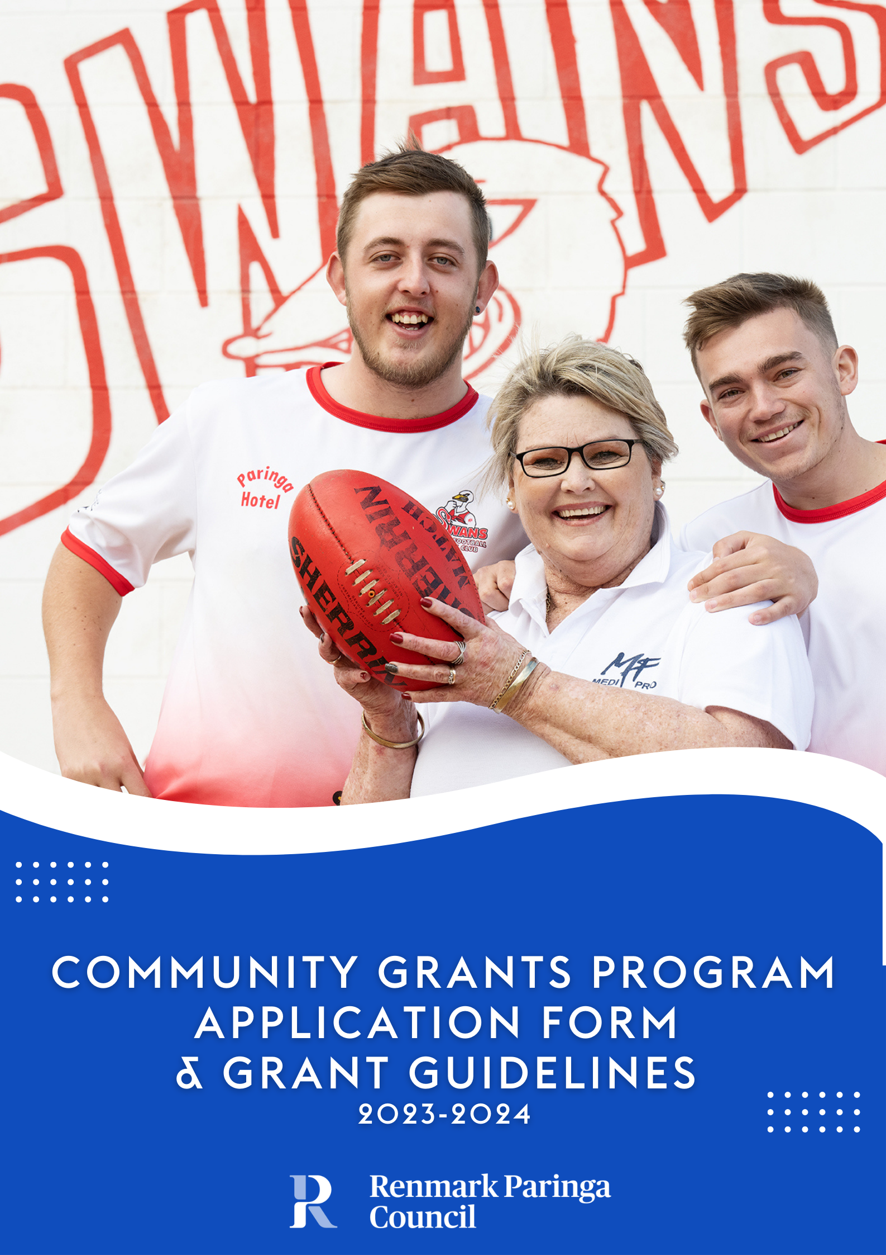

Renmark Paringa Council recognises and supports the major contribution that not for profit organisations provide to their local and wider communities.
Introduction

Council provides the Community Grants Program to support community projects, which aim to improve the quality of life of Renmark Paringa residents.

The Community Grants Program objectives are to:

- Promote strong community networks and mutual support; and contribute to the development and strengthening of local communities;
- Respond to emerging and specific needs of disadvantaged groups;
- Actively promote access and inclusion for people living with a disability;
- Promote community capacity and leadership;
- Provide support to community groups who experience restricted access to resources;
- Encourage community led development of services, facilities and events, which meet and enhance community needs and strategic objectives of Renmark Paringa Council;
- Promote active participation of local residents in community initiatives;
- Provide opportunities to develop skills and expand on knowledge;
- Facilitate positive social, economical and environmental outcomes for our community.

Grants of up to $4,000 will be made available for eligible community groups. Any project to receive funding will require the successful applicant to show a commitment by providing a contribution of 50% towards the cost of the project. This may be made up of cash and in-kind or cash only.

Applications may only be made for one of Council’s funding programs (Community Grants or Community Support Funding or Event Sponsorship) per financial year.

Community Grants Program Guidelines
Community organisations will be eligible to apply for funding if they can demonstrate that they meet the following criteria in their application and supporting documentation –
Eligibility Criteria

Application Process

What will not be Funded

- Must be an incorporated body or auspiced by an incorporated body. If auspiced by an incorporated body, the auspice body will be required to complete the relevant form agreeing (if the applicant is successful in obtaining funding) to receive the funding, expend the funds as per the funding agreement and ensure the project achieves the stated outcomes.
- Be a not-for-profit organisation.
- Be an organisation based within the Renmark Paringa area OR seeking funding for a project whose major emphasis is within the Renmark Paringa area.
    - An organisation whose project does not rely on recurrent funding from the Council for its continuance.
    - An organisation that is able to demonstrate they can meet the financial and project management requirements of the project.
    - Evidence that the project has been considered by the organisations Committee for example a copy of the minutes that include a motion that the Committee has agreed to submit a grant application to Council.

- Council will call for applications annually.
- All applications are required to be completed on the relevant application form with supporting documentation.
- If there is funding remaining, grant applications will continue to be assessed and allocated until the budget is expended (in the instance where 50% or more of the grants budget is remaining, a subsequent round may be considered and opened).
- No applicant can be guaranteed funding, nor can any applicant be guaranteed to receive the full amount requested
A
Things to consider prior to making an application
Applicants are required to seek the advice and assistance of Council staff if any of the following applies prior to an application being made:
- Any building or septic tank works, including alterations, additions or signage that may require development or planning approval.
- The project is within a Council owned facility or on Council owned land.
- If a lease or licence is held with Council.

- Ongoing staff salaries.
- Projects which are the funding responsibility of other levels of government.
- Individual financial assistance.
- Core school curriculum activities/infrastructure (something that occurs within school hours and the primary beneficiary are the school students of the applicant).
- A community group and/or project that has received funding in the last round. Should the full budget not be allocated, Council reserves the right to accept applications from previously funded groups and organisations. Potential applicants should seek clarification prior to applying by contacting Community Development staff.
- Operational expenses such as electricity, phone, internet, printing, photocopying.
- Requests for funding where a project has already commenced beyond planning and development of the concept.
- Applications and supporting documentation received after the specified closing date.
Community Grants Program Guidelines

All applicants will receive an acknowledgment email to confirm receipt of their application.
The Community Grants Program is a competitive source of funding. Applicants should aim to address and meet the objectives of the Program, which will form the basis for the assessment criteria. The success of an application will be determined on its merits against the assessment tool and in competition with other applications submitted. Applications that meet eligibility and address the assessment criteria are not guaranteed funding.
Assessment Process

Recognition

Accountability

Payment of funds

Administration will provide an assessment and recommendations to Council’s Grants and Sponsorship Committee regarding applications utilising an assessment tool. The Committee has delegated authority to make the final decision regarding funding of applications. Applicants will be advised in writing of the outcome of their application (successful or unsuccessful). Successful applicants will be provided with a funding agreement for review prior to payment being made. The funding decision made by the Committee is final.

It is expected that successful applicants will formally recognise the financial contribution made by Renmark Paringa Council whenever possible throughout the term of the project and at its completion. Council’s logo will be provided to successful applicants, and this can be used in any promotional material such as social media, flyers, brochures, or advertising. Where possible, an invitation may be made to Council to participate in any events that celebrate the project completion.

Successful applicants or auspicing bodies are required to comply with the following:
- Enter into a funding agreement that outlines the funding amount approved, conditions of the funding, acquittal requirements and other information relevant to the application. If the applicant is being auspiced then the auspicing body must also review and sign the funding agreement.
- Funds must be used for the purpose for which they were granted.
- Any variation in project scope or budget must be requested in writing and approved by the Grants and Sponsorship Committee.
- Funds must be expended by 31 May in the financial year the grant was approved.
- All relevant bank details are to be provided as part of the funding agreement process.
- If an organisation fails to submit an acquittal, they may be requested to return the funds and may be ineligible to apply for future funding.

- Payment of funds will be made to the applicant or auspicing body upon receipt of the signed funding agreement. Payment will be made by Electronic Funds Transfer (EFT) to the nominated bank account listed in the funding agreement.
- If the project is unable to be completed by 31 May in the financial year the grant was approved, the applicant should seek Council assistance as early as possible to ensure that funds do not need to be returned.

Community Grants Program Guidelines
- To enable payment of funds, all applicants must have an Australian Business Number (ABN). In the event that applicants do not have an ABN they must complete and submit a ‘Statement by Supplier’ form obtained from the Australian Taxation Office (ATO) website.

Acquittal Report

More Information

- Applicants do not have to be registered for GST however, where an applicant is registered for GST, the total funds will be grossed by 10% to cover the GST component that the applicant must pay to the ATO on receipt of the funds. Where an applicant is not registered for GST, the funds will remain the same. Notification of the groups GST status must be noted on the relevant application form.

Successful applicants must complete and return an Acquittal Report at completion of the project or before 31 May of the financial year the grant funds were approved in.

It is highly recommended that applicants contact Councils’ Community Development Team to discuss their proposed project prior to submitting an application.

8580 3000 or grants@renmarkparinga.sa.gov.au

Applications are to be completed electronically and submitted via –

Email | grants@renmarkparinga.sa.gov.au
Post | PO Box 730 RENMARK 5341
In Person | 61 Eighteenth Street RENMARK 5341

The 2023/24 Community Grants Program will remain open whilst funding exists or until the end of the 23/24 financial year (whichever comes first).
Applicants are advised that once their application is complete
(along with all supporting documentation) to submit their
application – details above for submission.

Community Grants Program - Application Form
Please refer to the Community Grants Program Guidelines (pages 1 – 5 of this document) when completing your application, ensuring that all questions are answered, and all supporting documentation is provided where requested. Incomplete or late applications will not be accepted.

1. Applicant Details
Organisation
Contact Person
Email
Phone
Postal Address
Are you not-for-profit? | Yes / No | Your organisation must be not-for-profit. If you are for profit, you are ineligible to apply for funding.
Are you Incorporated?  If you answered NO, please complete Auspice Body details below. | Yes / No | Incorporation Number
ABN Number*
Are you GST Registered? | Yes / No
*If you have answered no, you will be required to complete & return with funding agreement, “Statement by a supplier form – reason for not quoting an Australian Business Number (ABN) to an enterprise”. Copies available from ATO website.

2. Auspice Body Details (if applicable)
Auspice Body
Contact Person
Email
Phone
Postal Address
Incorporation Number |  | ABN*
Are you GST Registered? | Yes / No
Auspice agreement | Form completed and attached? Yes / No

3. Project Details (Assessment Criteria)
3.1 WHAT is your project? Describe the project, what are you going to do, when will the project happen, what benefit to the community will this project provide?
3.2 WHY do you want to do this project? Explain the need for the project, describe the opportunity, how the project will respond to community needs and why you believe the community needs it.

3.3 WHO will be involved? Who will manage the project, who will be involved, are there any partners, will there be voluntary and in-kind contributions?

3.4 HOW will the project be delivered and how will it be paid for?

3.5 DEFINE how you will know if your project was successful. What do you propose the outcomes/outputs to be and how will you evaluate this?

4. Budget
Copies of the previous 12 months audited financial statements OR a financial report that identifies the income and expenditure for the previous 12 months of the organisation must be provided.

INCOME
- what contributions your organisation will be making to the total cost of the project.
- what grant amount you are requesting from Council.
- is there any other funding that has been sourced.

EXPENDITURE
- include all project costs – all items that have a cost associated must be listed.
- quotes are required for all items of expenditure.

The total cash income and the total expenditure should equal the same amount.

4.1 Identify and address any ongoing costs as a result of this project:

4.2 If a lesser amount of funding is awarded, will the project still be able to proceed?
If your project will still proceed, how will you meet the funding shortfall?

CASH INCOME | AMOUNT | EXPENDITURE | AMOUNT
Your organisation’s contribution | $ |  | $
Council grant amount requested | $ |  | $
Other (please detail) | $ |  | $
 | $ |  | $
 | $ |  | $
 | $ |  | $
 | $ |  | $
 | $ |  | $
 | $ |  | $
 | $ |  | $
 | $ |  | $
 | $ |  | $
Total Cash Income | $ | Total Expenditure | $
In-kind/volunteer support | $
TOTAL PROJECT COST  Add together the total cash income and the total in-kind/volunteer support and this will result in the total project cost. | $

In-kind/volunteer support table
Goods/service to be provided (by whom) OR task performed by an organisation | Number of people | Number of hours | Rate per hour (skilled $45/hour, unskilled $20/hour) | Total Value  $
 |  |  | $ | $
 |  |  | $ | $
 |  |  | $ | $
 |  |  | $ | $
 |  |  | $ | $
TOTAL: |  |  |  | $

5. Declaration
I hereby certify that I have been authorised to prepare and submit this application on behalf of the above-mentioned group / organisation.

I declare that –

- We have read and understand the guidelines for the Renmark Paringa Council Community Grants Program
- The information supplied in this application is to the best of our knowledge accurate and complete.

Name
Position
Signature
Date

CHECKLIST – Please ensure the following have been completed/attached
Current quotes attached |  | Financial statements/report attached:
Evidence that the project has been considered by the Committee eg copy of minutes attached: |  | Auspice body agreement attached (if applicable):

Office Use Only

Date Received

Incoming Mail
Registration Number
Financial Amount
Requested by Organisation
Reviewed by Administration and
Grants & Sponsorship Committee
Outcome of Application

