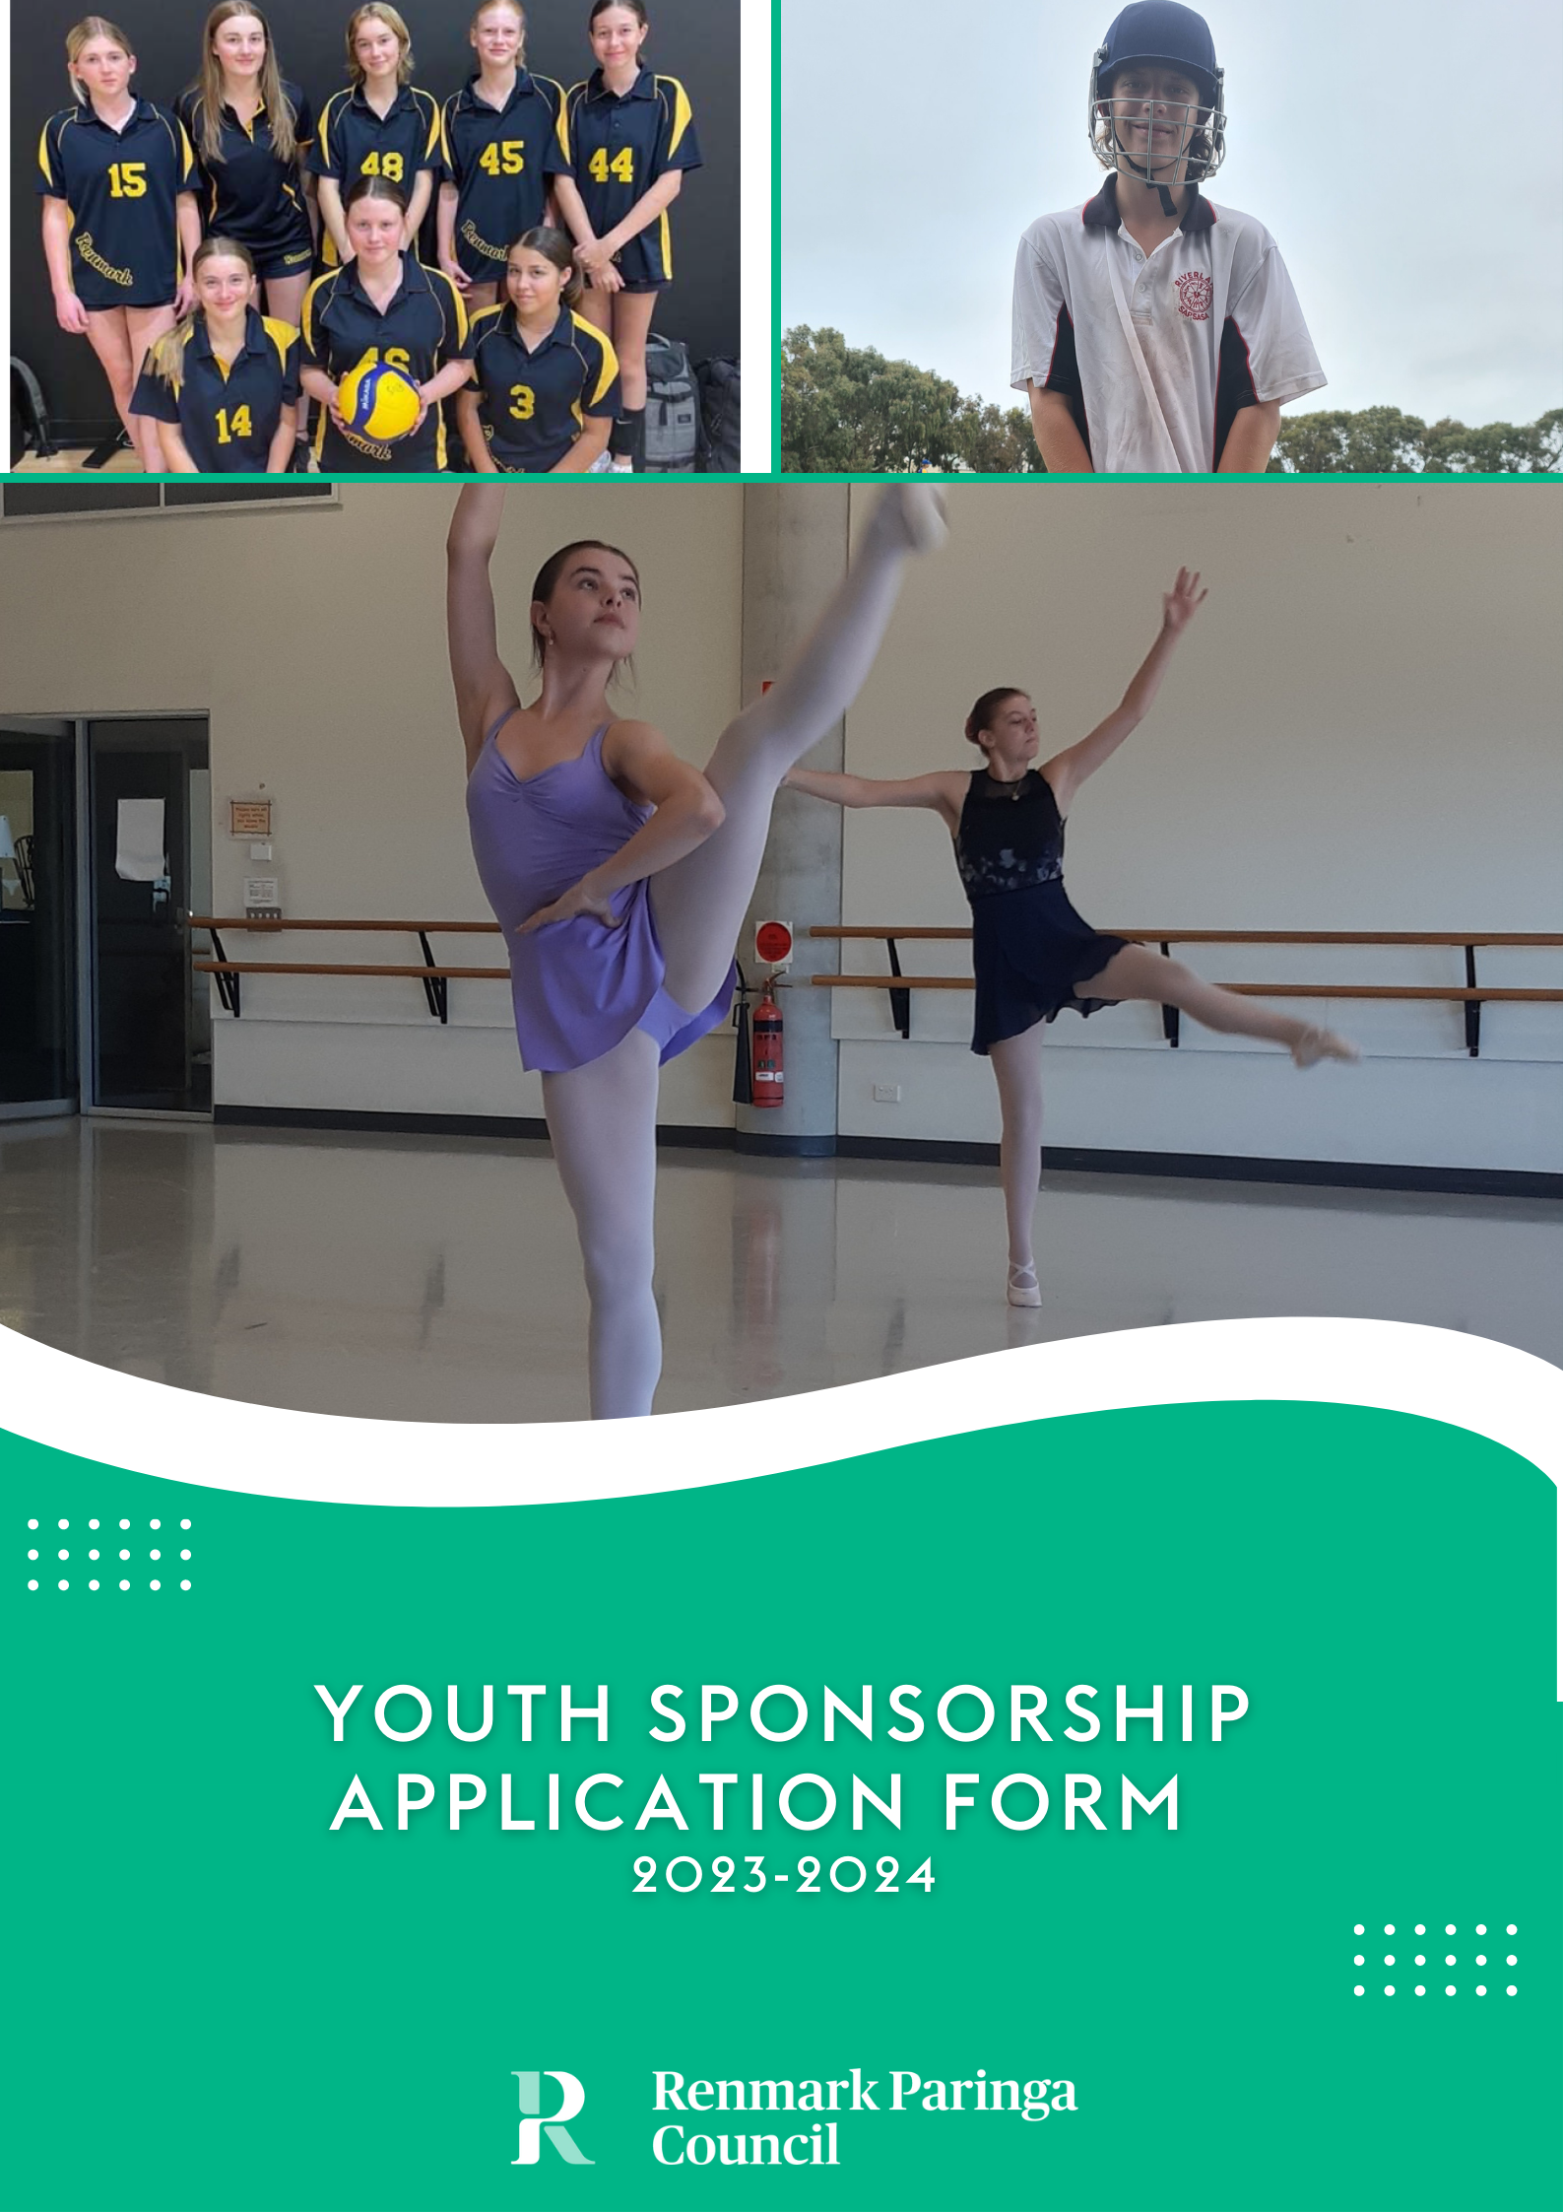

Council recognises the positive contribution young people make to the Renmark Paringa Council area and understands the importance in providing opportunities for their personal growth and capacity building.
Introduction

Youth Sponsorship aims to provide financial assistance to support and encourage young people to undertake skill development in competitions, events, or programs in their chosen field within the state, nationally and internationally. An annual allocation of up to 15% of the total Community Grants Program budget will be made available for youth sponsorship.

The Youth Sponsorship program objectives are to:

- Promote strong community networks and mutual support; and contribute to the development and strengthening of local communities;
- Respond to emerging and specific needs of disadvantaged groups;
- Actively promote access and inclusion for people living with a disability;
- Promote community capacity and leadership;
- Promote active participation of local residents in community initiatives;
- Provide opportunities to develop skills and expand on knowledge;
- Facilitate positive social, economical and environmental outcomes for our community.

Funding available
- An amount of $150 per person if competitions/events/programs are
held within South Australia;
- An amount of $250 per person if competitions/events/programs are
held interstate;
- An amount of $450 per person if competitions/events/programs are
held internationally.

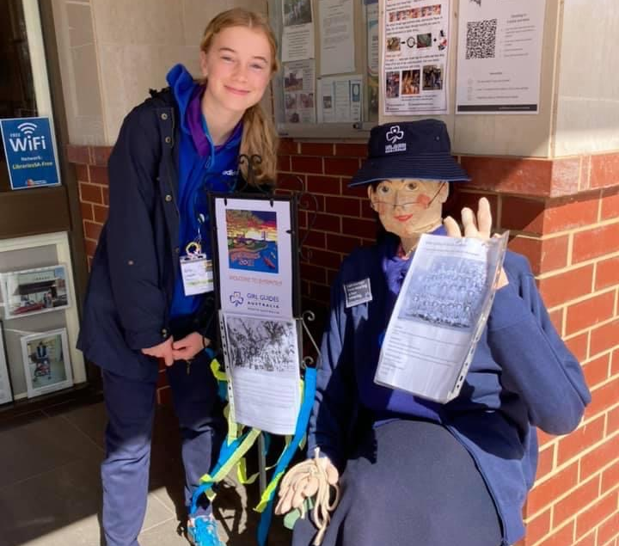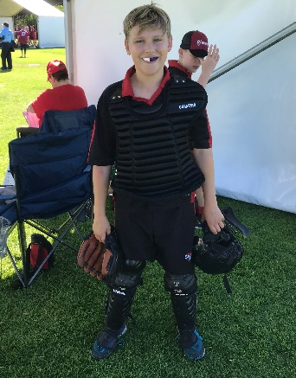
Youth Sponsorship Guidelines
To be eligible for funding, applicants are required to be:
Eligibility Criteria

Applications

Approval

Decision making process

Notification process

Payment of sponsorship

Recognition

- A resident of the Renmark Paringa Council area.
- Participating in competitions, events or programs representing the District, State or the Country within South Australia, Australia or internationally such as (but not limited to):
- Sport and recreation;
- The Arts eg visual, creative, performing, music, dance;
- Debating;
- Youth Leadership eg Youth Parliament, youth forums;
- Community, culture and heritage;
- First Nations;
- Environmental;
- Technology and innovation;
- Events or workshops that develop personal or professional skills and experience;
- Leadership programs or conferences
- Aged 24 years or under at the time of the event.
- Eligible applicants can apply and receive a maximum of 6 youth sponsorship approvals per financial year.

Applications made for Youth Sponsorship should be submitted on the relevant application form as early as possible and must be received prior to the competition/event/program. Sponsorship will not be provided on a retrospective basis. Council will call for applications annually.
A

Approval is subject to annual budgetary limitations.

The Manager Community Development has delegated authority to review and approve applications.

Youth Sponsorship applicants will be notified in writing advising of the successful or unsuccessful application.

When notification is made of a successful application, applicants will be requested to provide their bank details to Council to enable payment of the funds. Payment will be made by EFT.
In the instance that the event the applicant is attending is cancelled, funds are to be returned to Council unless the applicant can demonstrate that a considerable amount of the funds have been expended and are unable to be refunded.

Successful applicants (the youth member who received the funding) must provide a brief report of the event they participated in along with supporting photos within one month after attending their event. This report will be included in a Community Development information only report at a future Council meeting.
What to include in the report – some suggestions and ideas:
• What did you learn from the experience?
• Tell us about your favourite part/s of your experience?

Community Grants Program Guidelines
More Information

For any further questions, please contact Councils’ Community Development Team prior to submitting an application.

8580 3000 or grants@renmarkparinga.sa.gov.au

Applications are to be completed electronically and submitted via –

Email | grants@renmarkparinga.sa.gov.au
Post | PO Box 730 RENMARK 5341
In Person | 61 Eighteenth Street RENMARK 5341

Youth Sponsorship - Application Form
Please refer to the Community Grants Program Guidelines (pages 1 – 5 of this document) when completing your application, ensuring that all questions are answered, and all supporting documentation is provided where requested. Incomplete or late applications will not be accepted.

1. Applicant Details
Name of applicant
(if aged under 18 please also list name of parent/guardian)
Email
Phone
Residential and postal addresses
Date of Birth and age
Name of school or university attending
(if applicable)

2. Event details
Which category does
your event fit (please refer to guidelines)
Details of event
attending
Date/s of event
Location of event

(please tick)
 |  | event held within SA |  | event held interstate |  | event overseas
Name of group / club /
organisation, contact
name and phone number
that you are representing:
Cost to attend event: | Travel/transport costs (flights, petrol, taxi fees, car hire etc): |  |  | $
 | Accommodation: |  |  | $
 | Event registration: |  |  | $
 | Uniform: |  |  | $
 | Meals: |  |  | $
 | Other (please describe) |  |  | $

3. Declaration
We the persons making this application declare that we have read and understood the guidelines for the Renmark Paringa Council Youth Grants Program (if under 18, parent/guardian signature also required) and that the information supplied in this application is to the best of our knowledge accurate and complete.

Applicant signature
If under 18, parent/guardian signature
Date

Office Use Only

Date Received

Incoming Mail
Registration Number
Financial Amount
Requested by Organisation
Reviewed by Administration and
Grants & Sponsorship Committee
Outcome of Application

