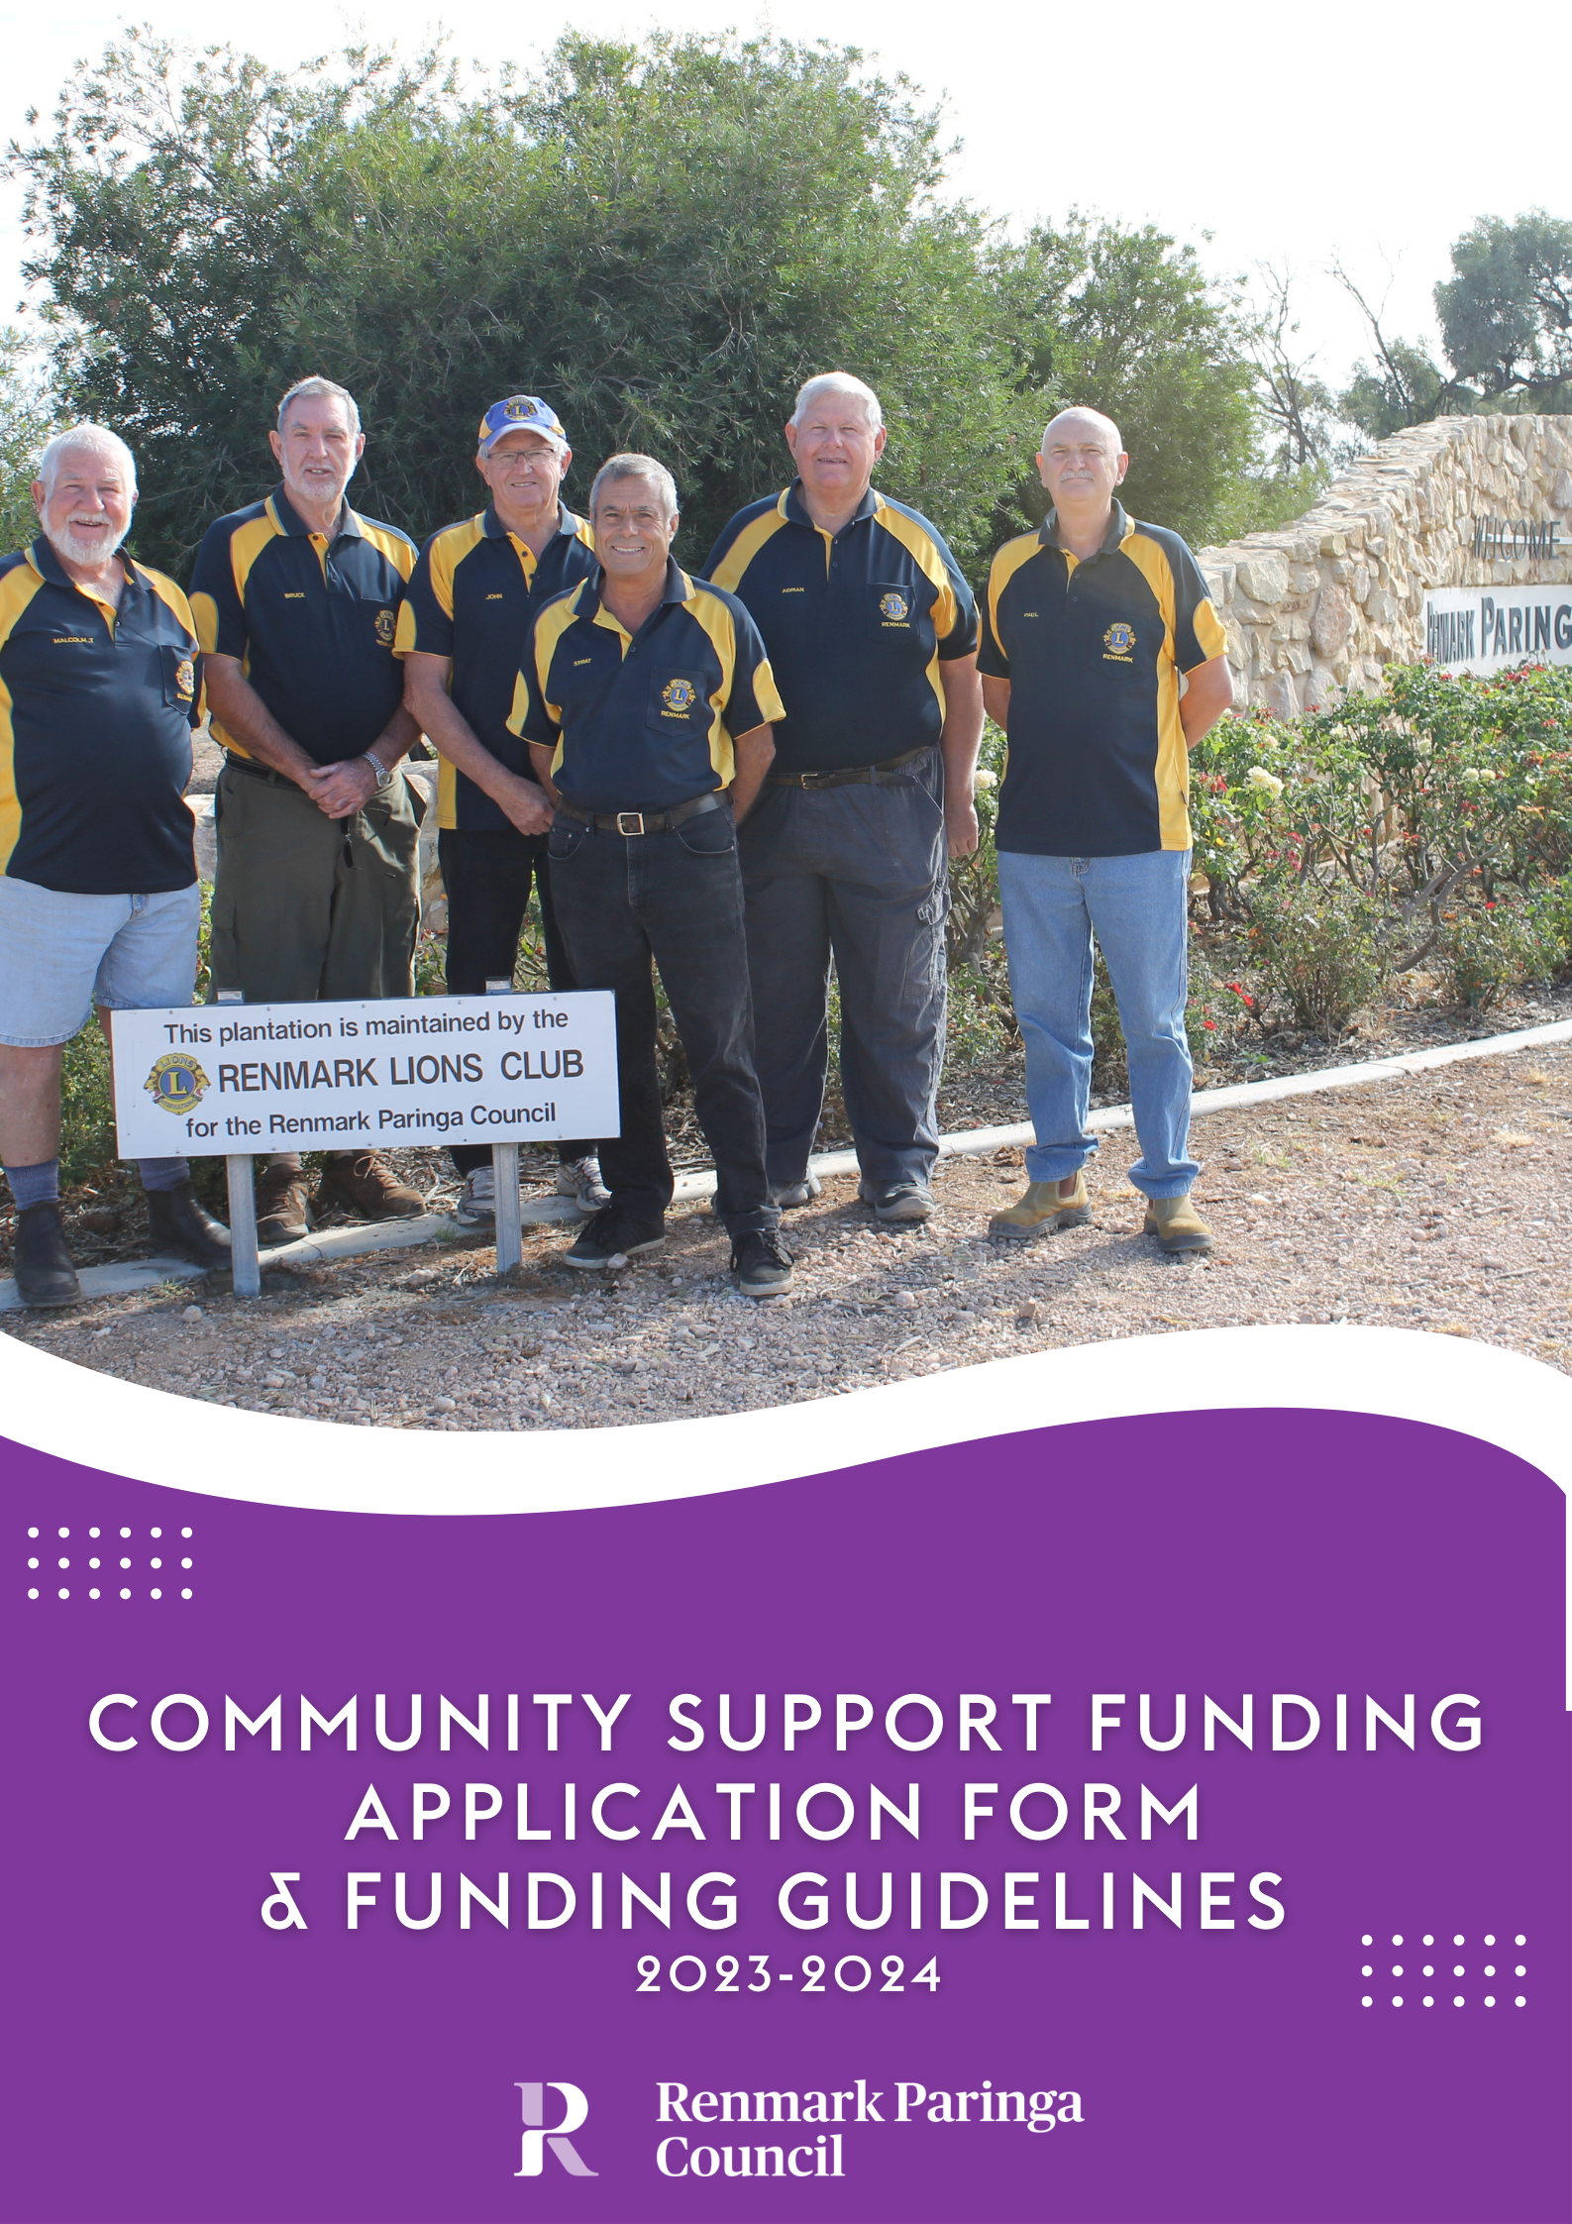

Renmark Paringa Council recognises and supports the major contribution that not for profit organisations provide to their local and wider communities.
Introduction

At the commencement of a new Council (every 4 years) applications will be considered and assessed to allocate funds to support local initiatives conducted by not-for-profit organisations in developing community service projects, social welfare and other community purposes.

The Community Support Funding program objectives are to:

- Promote strong community networks and mutual support; and contribute to the development and strengthening of local communities;
- Respond to emerging and specific needs of disadvantaged groups;
- Actively promote access and inclusion for people living with a disability;
- Promote community capacity and leadership;
- Provide support to community groups who experience restricted access to resources;
- Encourage community led development of services, facilities and events, which meet and enhance community needs and strategic objectives of Renmark Paringa Council;
- Promote active participation of local residents in community initiatives;
- Provide opportunities to develop skills and expand on knowledge;
- Facilitate positive social, economical and environmental outcomes for our community.

Donations of up to $5,000 cash (per financial year for the duration of the Council term) will be made available for eligible organisations.

Applications may only be made for one of Council’s funding programs (Community Grants or Community Support Funding or Event Sponsorship) per financial year.

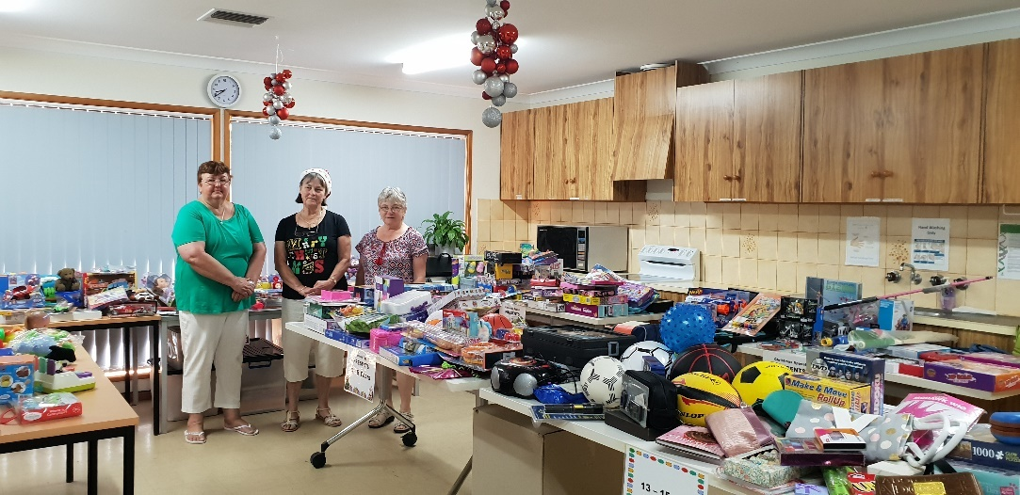
Community Support Funding Guidelines
Community organisations will be eligible to apply for funding if they can
Eligibility Criteria

What will not be funded

Application Process

Assessment Process

demonstrate that they meet all the following criteria in their application and
supporting documentation:
- Must be an incorporated body/legal entity
- Be a not-for-profit organisation.
    - Be an organisation based within the Renmark Paringa area OR seeking funding for services provided that benefit the Renmark Paringa community.
    - An organisation that is able to demonstrate they can meet the financial and project management requirements.

    - Ongoing staff salaries.
    - Programs which are the funding responsibility of other levels of government.
    - Individual financial assistance.
    - Core school curriculum activities/infrastructure (something that occurs within school hours and the primary beneficiary are the school students of the applicant).
    - Events – all applications for funding for events are to be made through Council’s Event Sponsorship program (see page 11 of this policy). Small community based events are excluded from this criteria and may speak to staff to clarify the funding program they are eligible to apply through.
    - Applications and supporting documentation received after the deadline.

- Council will call for applications at the beginning of each election cycle and will remain in place for the duration of the term.
- All applications are required to be completed on the relevant application form with supporting documentation.
- If there is funding remaining, grant applications will continue to be assessed and allocated until the budget is expended (in the instance where 50% or more of the grants budget is remaining, a subsequent round may be considered and opened).
- No applicant can be guaranteed funding, nor can any applicant be guaranteed to receive the full amount requested
The Community Grants Program is a competitive source of funding. Applicants should aim to address and meet the objectives of the program, which will form the basis for the assessment criteria. The success of an application will be determined on its merits against the assessment tool and in competition with other applications submitted. Applications that meet eligibility and address the assessment criteria are not guaranteed funding.

All applicants will receive an acknowledgement email to confirm receipt of their application.

Administration will provide an assessment and recommendations to Council’s Grants and Sponsorship Committee regarding applications utilising an assessment tool. The Committee has delegated authority to make the final decision regarding funding of applications. Applicants will be advised in writing of the outcome of their application (successful or unsuccessful). Successful applicants will be provided with a funding agreement for review prior to payment being made. The funding decision made by the Committee is final.

Community Support Funding Guidelines
It is expected that successful applicants will formally recognise the financial contribution made by Renmark Paringa Council whenever possible throughout the term of the funding and at its completion. Council’s logo will be provided to successful applicants, and this can be used in any promotional material such as social media, flyers, brochures, or advertising. Where possible, an invitation may be made to Council to participate in any events that celebrate the service being delivered.
Recognition

Accountability

Payment of funds

Acquittal Report

More information

Successful applicants of Community Support Funding are required to comply with the following:
- Enter into a funding agreement that outlines the funding approved, conditions of the funding, acquittal requirements and other information relevant to the application.
- Funds must be used for the purpose for which they were granted.
- Any variation in project scope or budget must be requested in writing and approved by the Grants and Sponsorship Committee.
- Funds must be expended by 30 June in the financial year the funding was approved.
- All relevant bank details are to be provided as part of the funding agreement process.
- If an organisation fails to submit the annual simplified acquittal, they may be required to return the funding and may be ineligible to apply for future funding.

- Payment of funds will be made to the applicant upon receipt of the signed funding agreement. Payment will be made by EFT to the nominated bank account listed in the funding agreement.
- If the program is unable to be completed by 30 June in the financial year the funding was approved, the applicant should seek Council assistance as early as possible to ensure that funds do not need to be returned.
- To enable payment of funding, all successful applicants must have an Australian Business Number (ABN). In the event that applicants do not have an ABN they must complete and submit a ‘Statement by Supplier’ form obtained from the Australian Taxation Office (ATO) website.
- Applicants do not have to be registered for GST however, where an applicant is registered for GST, the funding will be grossed by 10% to cover the GST component that the applicant must pay to the ATO on receipt of the funding. Where an applicant is not registered for GST, the funding will remain the same. Notification of the applicants GST status must be noted on the relevant funding application form.

Successful applicants must complete and return in the annual simplified acquittal before 30 June each financial year.

It is highly recommended that applicants contact Councils’ Community Development Team prior to submitting an application.

8580 3000 or grants@renmarkparinga.sa.gov.au

Applications are to be completed electronically and submitted via –
Email | grants@renmarkparinga.sa.gov.au
Post | PO Box 730 RENMARK 5341
In Person | 61 Eighteenth Street RENMARK 5341
The 2023/24 Community Grants Program will remain open whilst funding exists or
until the end of the 23/24 financial year (whichever comes first). Applicants are advised
that once their application is complete (along with all supporting documentation)
to submit their application – details above for submission.

Community Support Funding - Application Form
Please refer to the Community Support Funding Guidelines (pages 1 – 4 of this document) when completing your application, ensuring that all questions are answered, and all supporting documentation is provided where requested. Incomplete or late applications will not be accepted.

1. Applicant Details
Organisation
Contact Person
Email
Phone
Postal Address
Are you not-for-profit? | Yes / No | Your organisation must be not-for-profit. If you are for profit, you are ineligible to apply for funding.
Are you Incorporated or a Legal Entity? | Yes / No | Incorporation Number
ABN Number*
Are you GST Registered? | Yes / No
*If you have answered no, you will be required to complete & return with funding agreement, “Statement by a supplier form – reason for not quoting an Australian Business Number (ABN) to an enterprise”. Copies available from ATO website.

2. Project Details (Assessment Criteria)
2.1 WHAT are you going to do? What will the funding be used for? What benefit to the community will this service provide?
2.2 WHY do you want to provide this service? What are you aiming to achieve from this service?
2.3 WHO will be involved? Who will manage the service delivery? Are there any partners? Will there be voluntary and in-kind contributions?

2.4 HOW will the service be delivered and how will it be paid for?

2.5 DEFINE how you will know if your service was successful? What do you propose the outcomes/outputs to be and how will you evaluate this?

3. Budget
Copies of the previous 12 months audited financial statements OR a financial report that identifies the income and expenditure for the previous 12 months of the organisation must be provided.

INCOME
- what contributions your organisation will be making to the total cost of the project.
- what amount of funding you are requesting from Council.
- is there any other funding, sponsorship, donations etc that has been sourced.

EXPENDITURE
- include all project costs – all items that have a cost associated must be listed.

3.1 If a lesser amount of funding is awarded, will the project still be able to proceed?
If your project will still proceed, how will you meet the funding shortfall?

The total cash income and the total expenditure should each equal to the same amount.
CASH INCOME | AMOUNT | EXPENDITURE | AMOUNT
Your organisation’s cash contribution | $ |  | $
Council funding amount requested | $ |  | $
Other eg sponsorship, donations etc (please detail) | $ |  | $
 | $ |  | $
 | $ |  | $
 | $ |  | $
 | $ |  | $
 | $ |  | $
 | $ |  | $
Total Cash Income | $ | Total Expenditure | $
In-kind/volunteer support | $
TOTAL PROJECT COST  Add together the total cash income and the total in-kind/volunteer support and this will result in the total project cost. | $

In-kind/volunteer support table
Goods/service to be provided (by whom) OR task performed by an organisation | Number of people | Number of hours | Rate per hour (skilled $45/hour, unskilled $20/hour) | Total Value  $
 |  |  | $ | $
 |  |  | $ | $
 |  |  | $ | $
 |  |  | $ | $
 |  |  | $ | $
TOTAL: |  |  |  | $

4. Declaration
I hereby certify that I have been authorised to prepare and submit this application on behalf of the above-mentioned group / organisation.

I declare that –

- We have read and understand the guidelines for the Renmark Paringa Council Community Support Funding.
- The information supplied in this application is to the best of our knowledge accurate and complete.

Name
Position
Signature
Date

Office Use Only

Date Received

Incoming Mail
Registration Number
Financial Amount
Requested by Organisation
Reviewed by Administration and
Grants & Sponsorship Committee
Outcome of Application

